Milestone 3: Structured Writing, Multi-Paper Synthesis, and Reference Formatting

1. Objective
The objective of this milestone is to transform analytical insights generated in Milestone 2 into a professionally structured academic literature review. This includes automated generation of Abstract, Methods comparison, Results synthesis, and APA-formatted references using Large Language Models.
This milestone focuses on converting analytical reasoning into polished academic writing while maintaining logical coherence and formal structure.2. Environment Setup
The existing virtual environment was reused to ensure continuity across milestones. No new major dependencies were required beyond the LLM integration stack already configured.

3. Analytical Draft Integration
The analytical draft generated in Milestone 2 serves as the foundation for structured academic writing. Instead of regenerating insights, this phase focuses on refining and reorganizing the analytical content into formal research sections.
The system dynamically loads the analytical draft file corresponding to the selected topic and uses it as controlled input for structured generation.

4. Abstract, Methods, Result Synthesis Generation
A dedicated prompt-based generation module was implemented to produce a concise academic abstract, methodological approaches based on comparison and result synthesis.
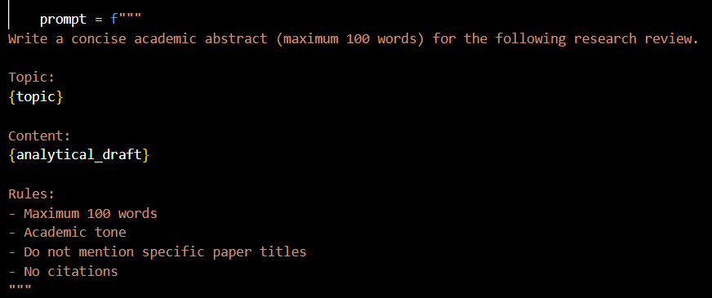

5. APA Reference Formatting
Research paper metadata collected during Milestone 1 is reused to generate APA 7th edition references. Instead of manual formatting, metadata is passed to the LLM with strict formatting instructions.
This ensures automated and standardized reference generation across topics.
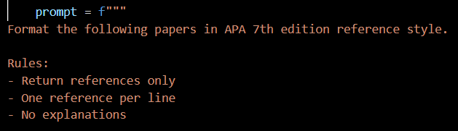

6. Structured Review Assembly
All generated sections are combined into a single structured output file
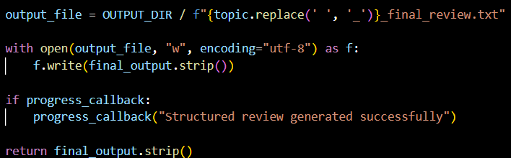

7. Output
Milestone 3 successfully transforms analytical insights into a fully structured academic research review. The system now produces professionally formatted sections that resemble human-written literature reviews.
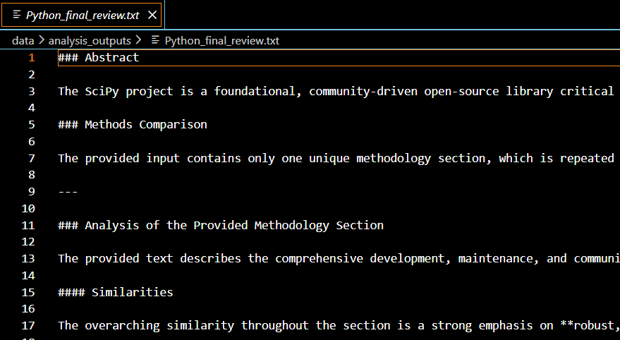

8. Conclusion
Milestone 3 advances the system from analytical reasoning to academic writing. By integrating structured drafting, dynamic multi-paper handling, and automated APA formatting, the project evolves into a semi-autonomous literature review engine capable of generating publication-style outputs.

